Thursday 16th July Buds Home Learning

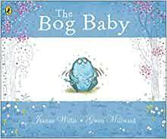
Bog Baby

Write the middle of your story

Spot the errors- Look at the text below and see if you can spot the errors.
amyand Jack wandered through the tall, towering trees of the wouldsthe trees reminded them of soldiers standing in a row. Should they be scared. They were a little bit lost but the sun was gleaming and it seemed such a beautiful day.

Today you are going to write the middle part of your story using your story plan. You should have already completed your ‘opener’ and the ‘build up’ so today you will focus on the ‘problem’ and the ‘resolution’

Here is an example of my ‘problem’

We snuck the small field ferret back into the garden and put him in the shed. We made him a little house from some old boxes and pots.
We wanted to show dad but we knew he would be angry so we kept him a secret.
We tried to take care of the field ferret but one day he became ill. He looked very sad and we were worried

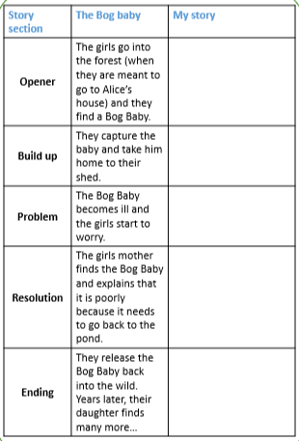

You can use the word bank below to help you. Remember to try and use ‘expanded noun phrases’ and ‘adverbs’ to add more detail to your writing as well as ‘conjunctions’ to extend your senetences.
























