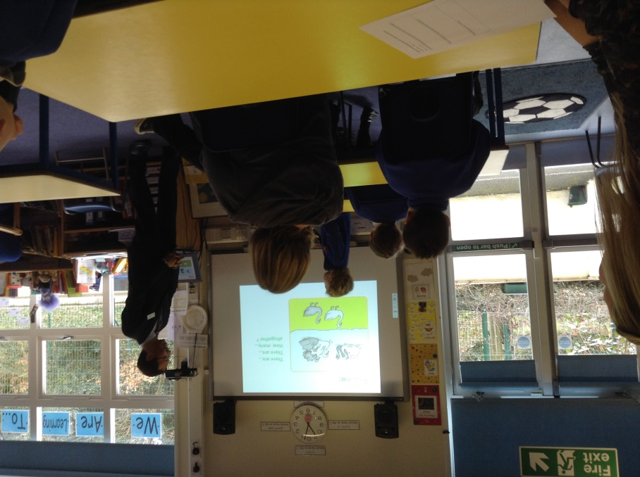
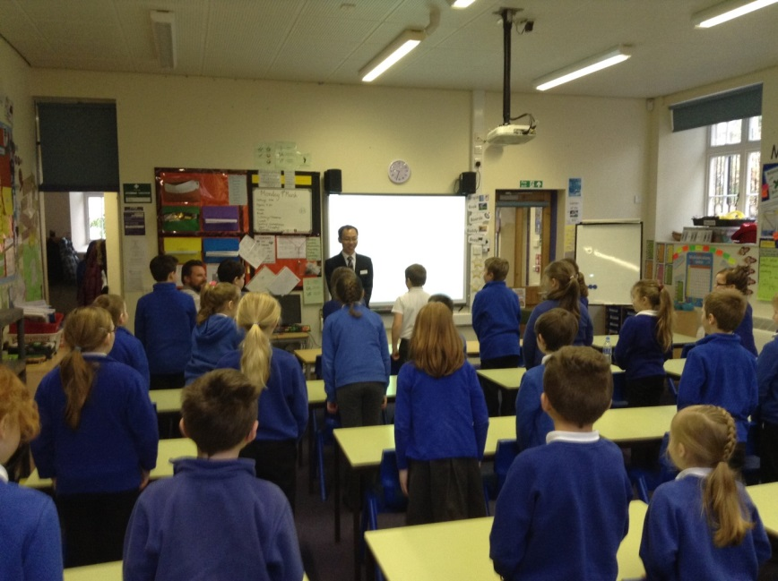
Day 1:Mr. Li has arrived at Chacewater School. We are ready to learn the art of mastery of maths.
Today we welcomed Mr.Li our Chinese teacher from Shanghai. He is teaching children in Year 1 and Year 3 and 4.
He started off the lesson by greeting the whole class as you can see in this picture. We stood up. We are all sitting in rows as well – this is a bit different.
In Year 3 and 4 we are learning about fractions. We spent the whole lesson talking about a whole and parts. We understood that “If…..is the whole , then ….is part of the whole. “
In Year 1 ,we learnt all about adding. We looked at pictures of different animals and had to make up stories about what we saw. We then turned these into “number sentences.” In this picture there are swans on the land and in the water. There are swans that are grey and swans that are white. There are swans facing one way and another. We had to decide what they would make “altogether.” In China, the different way of looking at one thing is called variation.

