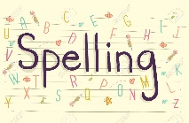
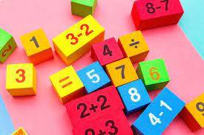
Spelling and Maths homework
QUIZ: Friday 24th September
Please find attached the 10 spellings for this week and the maths number fluency focus – remember these quizzes are on a FRIDAY! Good luck
Spellings  ee, ea, e-e, ey, e | Number Fluency  Number bonds to 8 and 9
sleep  thirteen  read  chimney  monkey  evening  beach  here  theme  she | 0 + 8 = 8  1 + 7 = 8  2 + 6 = 8  3 + 5 = 8  4 + 4 = 8  5 + 3 = 8  6+ 2 = 8  7+ 1 = 8  8 + 0 = 9  0 + 9 = 9  1 + 8 = 9  2 + 7 = 9  3 + 6 = 9  4 + 5 = 9  5 + 4 = 9  6 + 3= 9  7 + 2 =9  8 + 1 = 9  9 + 0 = 9  Please practise playing different games to help you learn these bonds!

