17 Station road. 22nd April

Dear Mother Earth,

I am writing to you because I want to save you. The earth is Important to me because the earth is the only earth there is.

I love orangutans but they’re dying because people are chopping down trees for palm oil. We have to stop Sainsbury’s and other shops using Palm oil.

I’m going to save you from the evil plastic in the sea. The plastic in the sea floats around and turtles think plastic bags are jellyfish. The crabs are trapped in grape boxes and fish are trapped in plastic nets and fisher men catch fish and use sharks fins in soup. Octopus are in danger because of dirty water and there habitat being destroyed by humans.
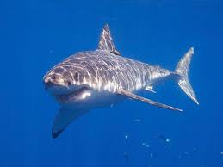
Love Wes.
