Seedlings Topic Homework
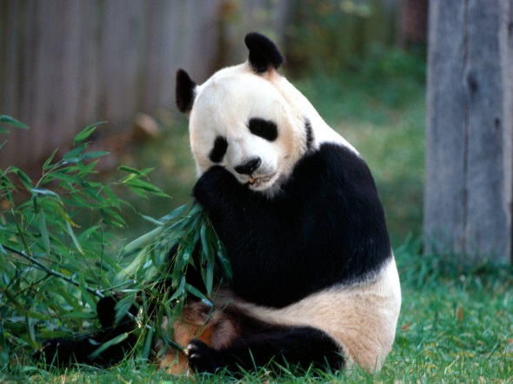
Animal Allsorts
This term our topic is all about animals and for their homework, the seedlings are required to create a project about an animal of their choice – try to encourage them to be as daring as possible with their choice!
They can choose the way they present their project (powerpoint, book, poster, photographs, pictures, writing, acting etc) and have until w/c – 23rd May to complete it.
I would like them to ensure that they cover all of these areas within their project:
- The animals appearance
- Where they live
- What type of animal they are
- What they eat
- What they hunt or whether they are hunted
- Any interesting facts
Enjoy creating this project with your child, I can’t wait to see them!

Any questions, please do not hesitate to ask,

Many Thanks

Mrs Fox
(Seedlings Teacher)

