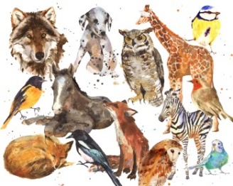
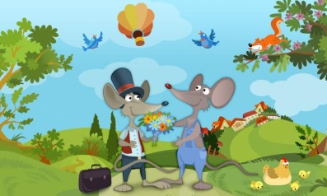
Buds Curriculum Letter Year 2
Spring Term
Dear Parents,
Welcome Back: Welcome to the Spring Term, following from a successful Autumn term. We would like to start by thanking you for supporting your child with their homework project linked to ‘Flying High’ and the wonderful costumes.
Topic: In this topic the pupils use the story of the ‘Town Mouse and Country Mouse’ to explore a contrasting UK locality. We will be visited by a tractor to find out about life in the countryside and learn all about living things and their habitats. Please can your child bring wellies into school for Monday lessons, as some of our science learning will take place outside.
In the second half of term our topic will be exploring commercial farming and growing our own food and plant products, the conditions necessary to do so and the ways plants can be used, ‘Sowing and Growing’.
English: This term we will be continuing to read in small groups; RWINC and the Accelerated Reading programme as well as whole class shared reading on a Tuesday and Wednesday for all children. We will be preparing the children for the New National Test and at the same time encouraging the children to have a love for reading and teaching the necessary reading skills as part of the curriculum. In writing, we will be writing non-chronological reports about Mice and then moving onto character descriptions. Our first class novel we will be sharing is ‘The Owl Who was Afraid of the Dark’ and then ‘Hodgeheg’ by Dick King-Smith.
Mathematics (daily 60 minute sessions): We will be focussing our learning on Number and Place value, Mental addition and subtraction, Mental multiplication and division, Geometry, Statistics, Measurement. Thank you for your support with maths homework which will continue to be set weekly. In addition you can help your child by logging onto Espresso website. All children need to know their 2, 5 and 10 times tables by heart and start to learn the rest and to know the addition and subtraction number pairs of 10, 20 and 100. Having these number facts at their fingertips helps children to make good progress.
Physical Education: Our PE sessions this half term, will be Tuesday swimming lessons and a Wednesday afternoon, gymnastics with Mrs Saxton. Can we request that any children with long hair have their hair tied up on PE days and that they have the correct PE kit in school at all times (blue T-shirt, black/white shorts, trainers/plimsolls). If your child has their ears pierced, it is recommended that they do not wear earrings on these days; however if you are unable to remove them tape is applied over them to prevent injury.
Science: We will be learning all about living things and their habitats. We will understand the differences between living and non-living, the places where animals live and why they are best suited to those habitats. We will identify plants and animals in their habitats, including micro-habitats.
History/ Geography: We will be using maps to identify countries of the United Kingdom. Using globes, we will identify the seven continents and five oceans, we will learn about the compass points and why they are used. We will use aerial photographs and plans to recognise landmarks and basic physical features. We will use symbols to represent places on a map.
Art/ Design and Technology: We will complete making a vehicle designed for a Town Mouse and Country Mouse which will travel down a slope.
Music: Children will learn to classify instruments into groups and learn a chant by matching an instrument to an animal. We will create soundscape environmental sounds and describe them.
PSHE: Our focus this whole term throughout the school is; Feelings and emotions: recognise feelings in self; special people; behaviour and how people’s bodies and feelings can be hurt. Healthy Relationships: secrets and surprises; working together; boundaries and relationships; resolving conflict; teasing and bullying. Valuing difference: Attributes: kindness/fairness; sharing and respecting opinions; recognising and respecting similarities and differences
Computing: We shall be focusing on our presentation skills and creating our own powerpoint presentation, entering text and pictures.
Homework: Spellings will continue to be given out on Fridays and tested on a Friday morning. Maths homework will be given out on a Thursday to be handed in on the following Wednesday; this will be in your child’s folder.
Children need to change their individual reading book daily, or as necessary with longer texts, and record the title in their Reading Record Book which is handed into their group basket every morning. We will be regularly checking reading records in order to comment on reading in school and to respond to any queries or celebrations about your child’s reading that you have.
Thank you for your continued support. If you have queries regarding the work this term please don’t hesitate to speak to a member of the Buds class team!
Yours sincerely,
Danielle Morgan and Julie Saxton

