Chacewater School Council Project
Autumn term 2016-2017
British Heart Foundation Skipping Event
At the beginning of the Autumn term we started our skipping event within our indoor PE lessons. All children took part in this over 6 weeks, where Mrs Morgan and Grace delivered these sessions. Skipping ropes were available to use within break time sessions too and with skipping skills cards available.
Three assemblies were held to firstly explain why we were holding a fund raising events and how skipping can improve health. The second assembly, we began to show some of the children’s skipping skills and watched some inspiring videos of skipping to encourage children to skip in their free time. The third assembly showed the total we had raised which was £722.30 which meant the school council were able to keep 20% of the funds raised: £144.30 for our next project. The school and children benefitted from this for long life participation, increasing our physical activity during break and lunch sessions but also allowing us to keep the skipping ropes.
The Skip Off event took place on November the 13th in the afternoon. Year groups worked together, Year 6 and Year 1, Year 3/4, Year 2 and 5. They rotated between the 3 areas, outside for speed skips and group skipping, classroom for poster work about the British Heart Foundation and the hall for skipping relays and skipping skills. The whole school took part in an outdoor wake and shake which the children had been learning in our Wednesday morning wake and shake sessions.
Here are some of the photographs to show our skipping event:
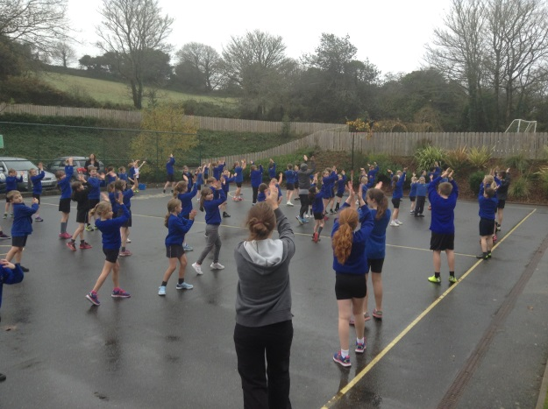
Whole school Wake and shake

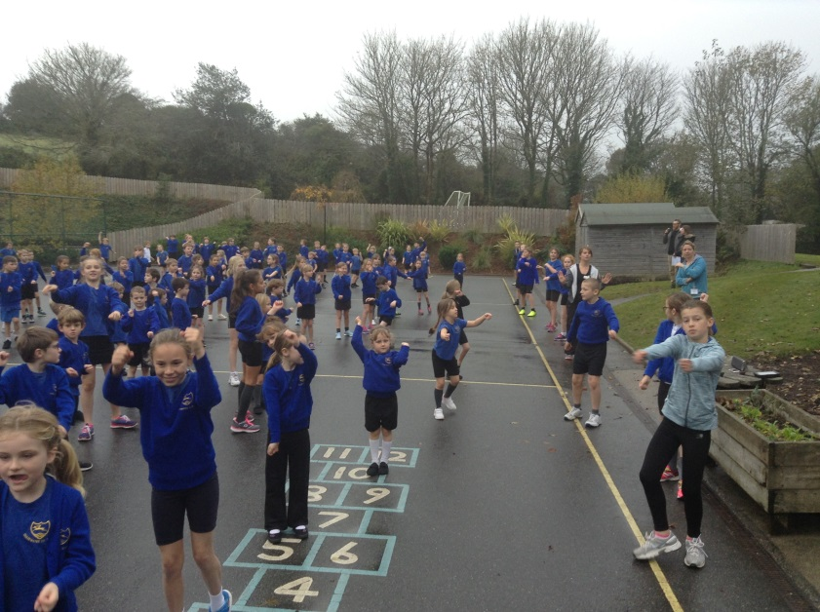
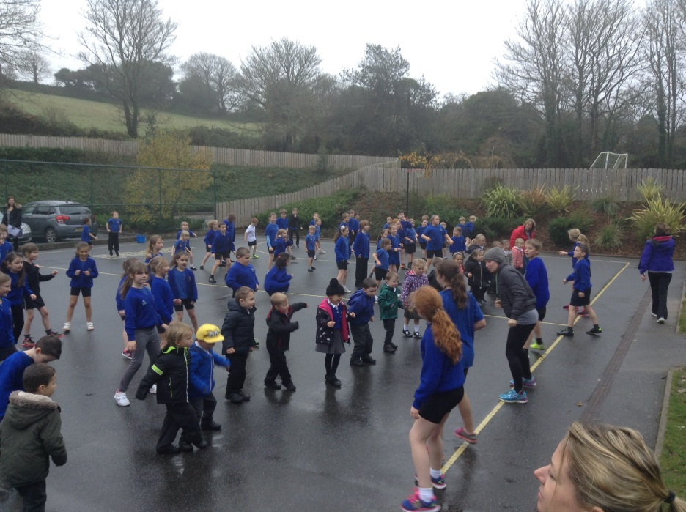
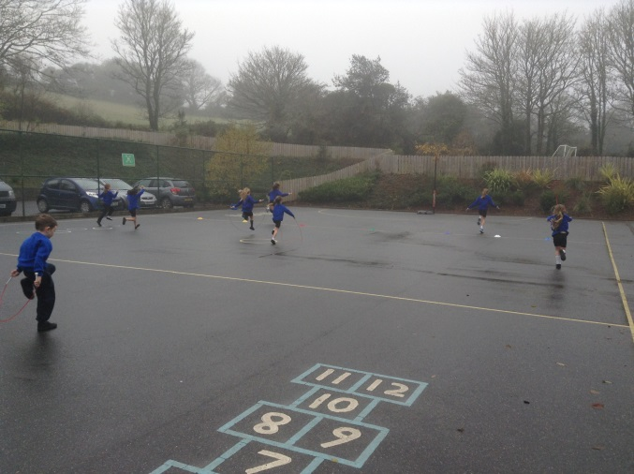Skipping races
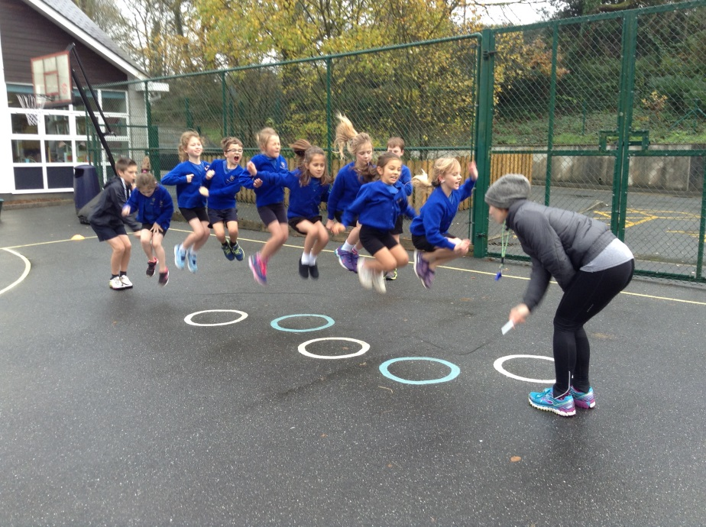 Group skipping
