Thursday 16th July Buds Home Learning

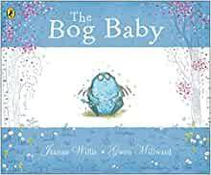
Bog Baby

Read the two pages and answer the questions. You can write your answers down or just talk about the questions with your adult.
