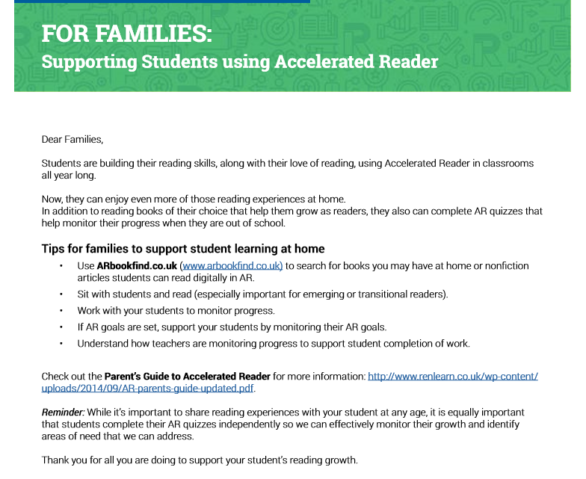

This is the email address for Accelerated reader:
https://ukhosted40.renlearn.co.uk/2234842/Public/RPM/Login/Login.aspx?srcID=s

Children should know their email addresses and passwords. If any problems, contact your class teacher by email.

