Starting School
at
Chacewater School

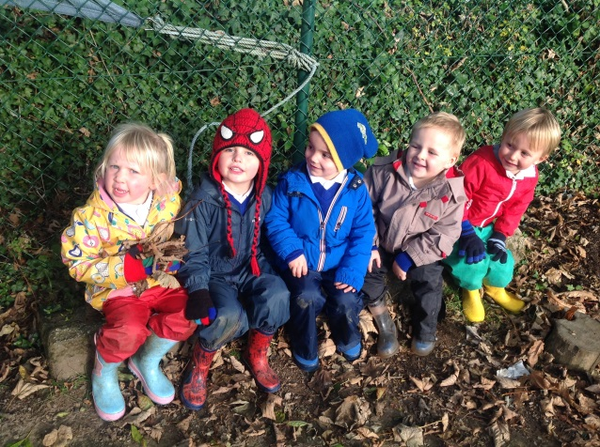

Church Hill
Chacewater
Truro
TR4 8PZ
Tel: 01872 560302
Email: head@chacewaterschool.co.uk
Web: chacewater.cornwall.sch.uk
Twitter: @chacewatersch

CONTENTS

Starting school at Chacewater 3
The staff 3
Autumn term start dates 2017 3
Class Structure 4
Partnership with parents ………………………........................................... 4
The first day at school 4
The start of the session 4
The end of the sessions 4
Toys 5
Newsletters ………………………………………………………… 5
Uniform 5
PE bags 6
Snack time 6
Cooking in Acorns Class 6
School dinner or packed lunch ? ………………………………………… 6 Health 7
Asthma 8
Chacewater School PTA 8
Getting ready for school 9
The curriculum ………………………………………………………………. 10
Learning Journey 11
Foundation Stage Profile 11
Common questions and concerns 12
And finally! 14
School Year Dates ……………………………………………………… 15

Starting School at Chacewater
All of us here at Chacewater School extend a warm welcome to you and your family. For every child the step from home, nursery or pre-school to school is a very important one. This booklet has been put together to help make your child’s first days at school a happy experience for them and for you, and to help them to settle in to school life as quickly and easily as possible.

The Staff

Mr Chris Gould The Headteacher
Mrs. Susan Hodgson School Secretary
Mrs Kerry Rice Class Teacher
Mrs Kate Whitehead Higher Level Teaching Assistant

Term Dates 2017-18

Please see the last page of this booklet for all dates for the school year. Please note that there will be two more Staff Training Days throughout the school year, but these have yet to be confirmed. You will be informed of these dates in due course.

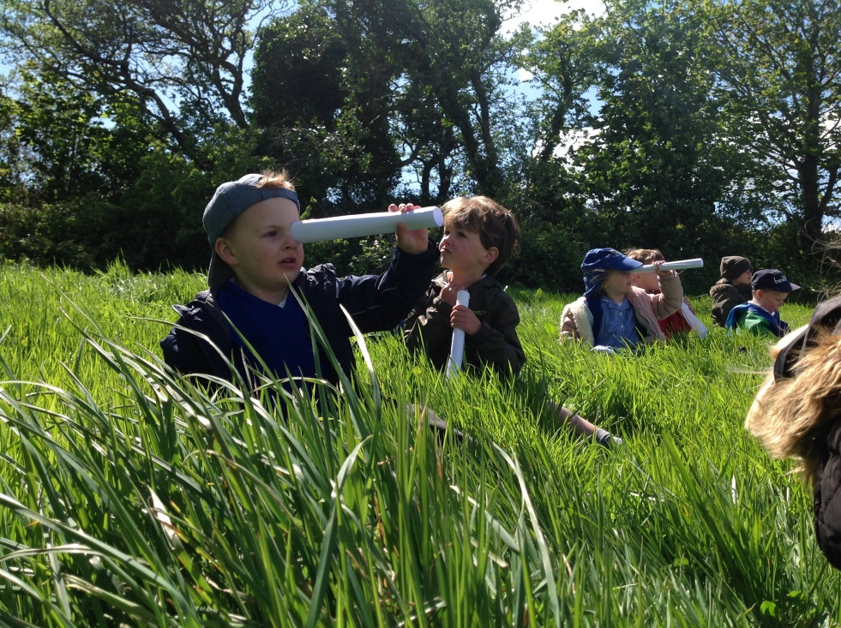

Reception age children will be starting school on Wednesday 6 September.

Class Structure

Your child will start school in Acorns Class and be taught by Mrs Rice.

Partnership with Parents

We value our relationships with parents highly and will do our best to include you in your child’s exciting journey of education. You, as parents, are a child’s first and most important educators and you will continue to play an enormous part in their education over the next 12 years at least! The interest you take in your child’s education and the value you place upon it are vital to your child’s success.

There are regular opportunities throughout the year for parents to come into school and talk with teachers and other staff, but our
day-to-day contact with parents is our most important means of
communication.

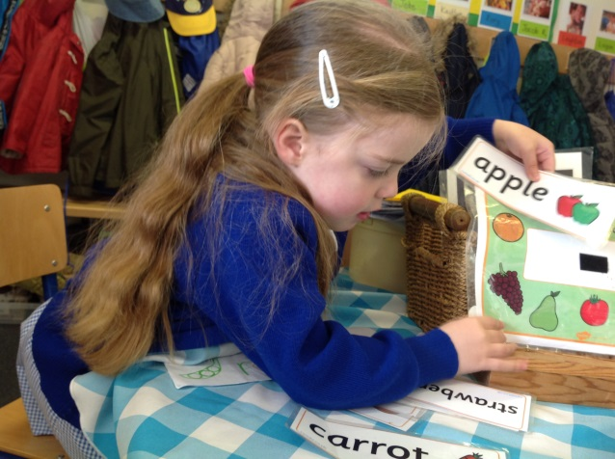

Please talk to us immediately if you have any concerns. If you need more than a few words at the beginning or end of the day, we will arrange a convenient time. If you are working and do not bring your child to school, please send in a note and we will telephone you to talk through any concerns you may have.

The Start of the Day

In the mornings all children enter the school via the main gates or the side gate at the top of the recreation ground. The school is open from 8.40am. Parents of Reception children are welcome to bring them into the classroom and support their child in hanging up their coat, putting their water bottle in the bucket, lunchbox in the fridge and changing their book. Staff welcome children individually and are available to talk briefly with parents. The children are encouraged to settle quietly to an activity at a table or on the carpet until the bell rings at 8.55 am. This is the signal for the start of the session and any remaining parents should leave the classroom at this time.
The end of the school day is 3.15pm

Children are dismissed from the double doors into Acorn’s outdoor area. Please wait where you can be seen so that the teacher can send your child straight to you.
We take great care to dismiss children only to their parents or other regular carers, so if someone different will be collecting your child it is very important to let us know.

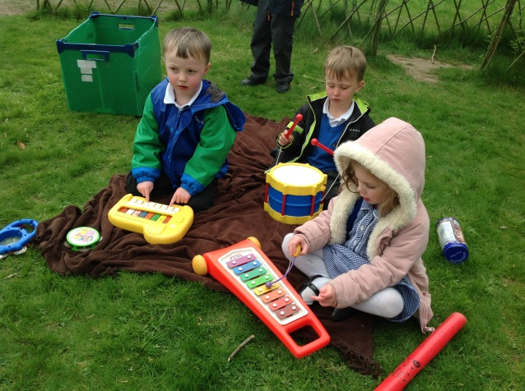
Toys

We have found that toys are best
left at home. Our Class has lots of toys for the children to play and learn with. There will be occasions where we ask children to bring in contributions from home for our displays, or will be allowed to bring in a toy for a special treat, and a letter will always be sent home on these occasions. We are very grateful for your support with this.

Newsletters

Whole school newsletters are published every Friday throughout the term. These keep you informed about what is going on at school and tell you about ways in which you can help. They will be emailed to you weekly or check our website for these newsletters, or any other letters from us. If you prefer a hard-copy please let the School Secretary know.

Uniform
- Black or grey skirt, pinafore, culottes/ trousers
- White shirts/blouses (Polo shirts are easier for children to manage independently.)
- Royal blue knitted jumper or cardigan with school logo.
- Black shoes (Velcro fastenings are easier to manage than laces.)

In summer the girls may wear blue and white check dresses and the boys may wear black/grey shorts with white polo shirts.

All school uniform is available from Trophy Textiles. There is a link on the school website.

It is very important that all clothing is named.

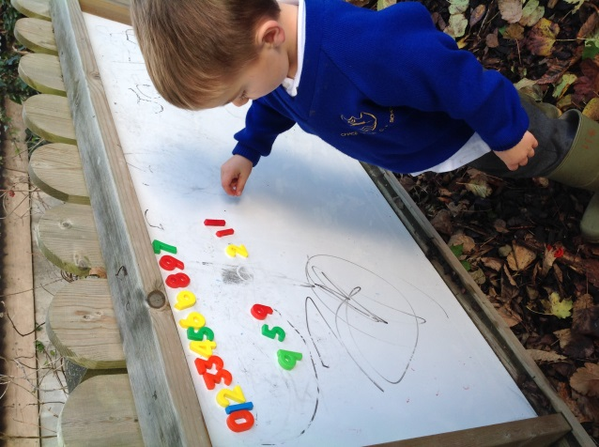

We do endeavour to keep the children clean at school but this is not always possible so please make sure that all clothing is washable.

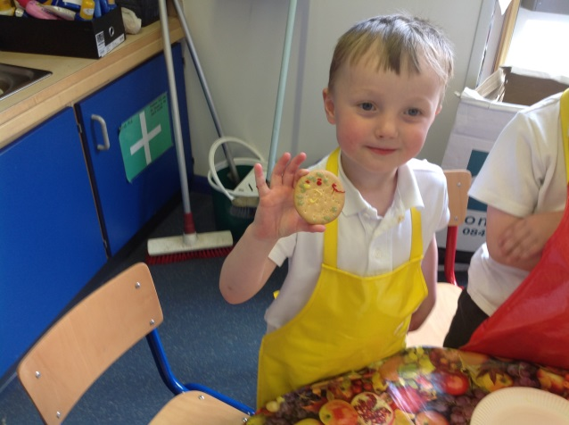

PE Bags

All children need a drawstring PE bag (these can be ordered from Trophy Textiles). This is kept at school during term time. The bag should be clearly labelled with the child’s name.
Inside there should be:
- a pair of black shorts
- a blue Chacewater School
t-shirt
- a pair of plimsolls with elastic or Velcro fastening
- a pair of socks

All these items should also be clearly named.

We send the PE kit home at the end of each half term so that it can be washed.

Big Bags and Rucksacks

The children do not need rucksacks or other kinds of large ‘school bags’ until they are older. Chacewater School book bags can be ordered from Trophy Textiles along with other uniform items they will need.

Snack Time

The children are provided with a mid-morning snack of fruit.

Children under 5 also receive free milk. There is an option for parents to pay for milk for children once they are 5 years old.

Cooking in Acorns Class

We try to provide opportunities for children to prepare cook and eat food. Please could you advise Mrs Rice or Mrs Whitehead of any food allergies that your child has. We ask for an initial contribution of £4 from each family to cover the costs of ingredients. This contribution can be given to Acorns’ staff at the start of the school year.

School Dinner or Packed Lunch?

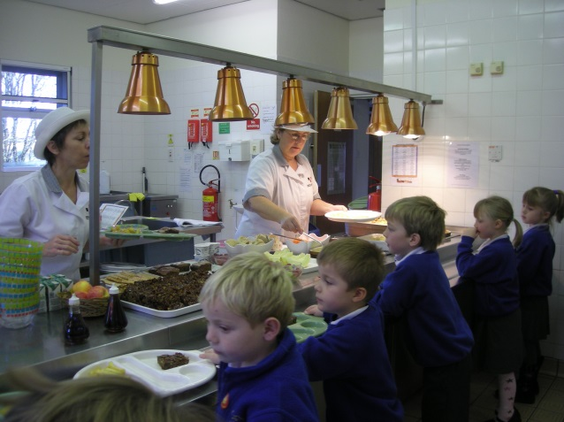

School Dinners

All infant children are provided with a paid for school dinner. There is a daily choice of two set meals. Your child will eat their meal in Acorn’s classroom.
In the first few weeks of term you will receive log-in details for ParentPay – the electronic ordering system. You can then create your own account to pre-order your child’s meals. See separate pack from Eden.

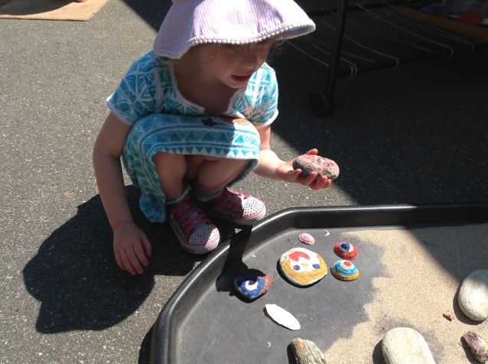

Packed Lunch

If your child prefers packed lunch, please include the food your child really likes. We want to avoid children saying that they don’t like what is in their sandwiches! Most parents of young children send far too much and this can be a bit daunting. Try to send approximately the amount that your child would eat at home. We like to encourage children to eat healthily and would appreciate your support with this. Remember to pack a spoon for yoghurt, a drink (or we provide water at school) and a napkin or a piece of kitchen roll. Mini ‘cool packs’ help to keep lunches fresh in the summer.

Warning!

Please note that uneaten and half eaten food, empty food cartons and packets are sent home rather than thrown away at school so that parents can monitor what has been eaten. Beware, it can mean that lunch boxes can get a bit messy!

Health

When your child starts school, you will find that he or she is quite tired at the end of the day even if they have attended a pre-school setting. This is quite natural and to be expected.

Please do not let your child make the decision about attendance. Adults must take that responsibility. At home with Mum or Dad is the best place for a child who does not feel well. Some children will protest to return to school, but you know your child and will be able to judge the best course of action to take.

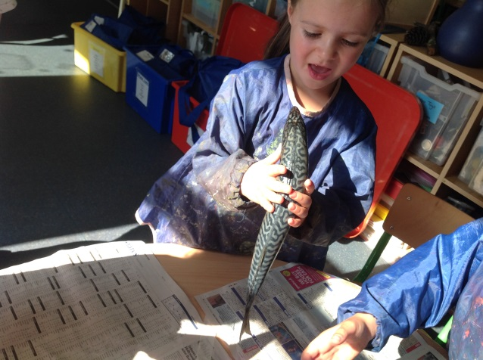
Here are some guidelines to help you:

- No child should attend school with a temperature. Gastric upsets need 48 hours for recovery after the last bout of diarrhoea or sickness. If children return to school too early they bring infection with them and their resistance is low

- Conjunctivitis and impetigo are extremely contagious and should be treated, and disappear before the child returns to school.

- Children on antibiotics should really be at home unless the doctor advises otherwise. In some cases, medicines prescribed by your GP can be administered at school, but we have to follow strict procedures for this. Forms need to be completed at the school office and medicines handed in there. We do not keep medicines in the classroom

- The school should be notified of any infectious illness so that other parents can be warned

- If you find your child has head lice, please report the case to school and keep the child at home until you have treated the whole family

It is school policy to contact parents if a child is unwell at school or has an injury that may require medical attention.

If your child is not well enough to attend school it is essential that you inform us by telephone on 01872 560302, before 9.00 am.

Asthma

It is important that children who suffer from asthma have access to their own, named, inhalers at any time and we arrange with each child where they will be kept.

Please keep us informed about your child’s particular needs.

Glasses

If your child wears glasses please try to have a second pair that can be kept in school so that we can support regular wear.

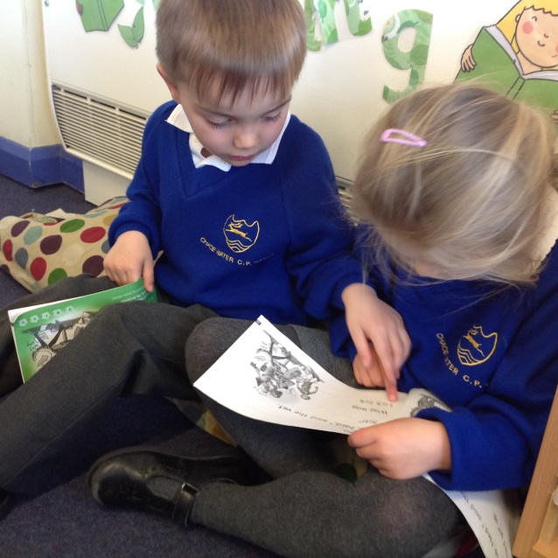
Friends of Chacewater School

The Friends support the school community in many ways. They hold fetes, barbecues, sponsored and social events over the year.

Friends of Chacewater School meet regularly during a term to discuss forthcoming events. The meetings are informal and fun. The Friends are always delighted to welcome anyone who is interested in finding out more about becoming involved in activities and helping to raise money for the school. The Friends also offer a great opportunity for all parents, both old and new, to get to know the school and each other a little better.

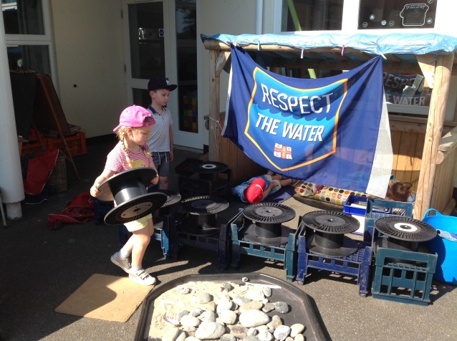

Getting Ready for School

Starting school is a big step for your child and we hope to make this transition as smooth and problem free as we can. As parents you can help your child become more independent and confident by helping them to master the following skills:

- Teach your child to dress and undress independently. We find that Velcro-fastened shoes, rather than laces and buckles, are very helpful. Practise with the PE kit so your child is familiar with getting it on and off independently.

- Show your child how to remove their coat without the sleeves turning inside out. Doing up a coat zip or fasteners is also a skill that takes time to master. Teach them how to hang it up using its hook so that it does not get knocked straight onto the floor. (If the coat does not have a hook it helps greatly if you can sew in a piece of tape or ribbon). Please make sure that the coat is named.

- Make sure that your child can use the toilet properly, flushing and then washing hands carefully afterwards.

- Once at school, it is helpful for children to organise their own belongings so that they know where all their things are. So please encourage them to be independent and step back when you can – for example encourage your child to hang up their own coat and place their book bag and water bottle into the correct boxes in the mornings.

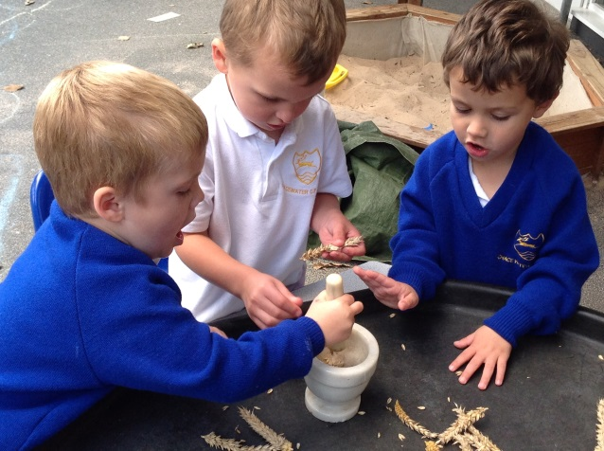

The Curriculum
Play underpins all development and learning for young children and it is through play that children develop intellectually, creatively physically, socially and emotionally.
In Acorns Class activities and experiences are planned to support children to learn with enjoyment and challenge. The children have opportunities to play indoors and outdoors throughout the day.

We follow the Early Years Foundation Stage curriculum for children from birth to 5 years which states that:

Play is essential for children’s development, building their confidence as they learn to explore, to think about problems and relate to others

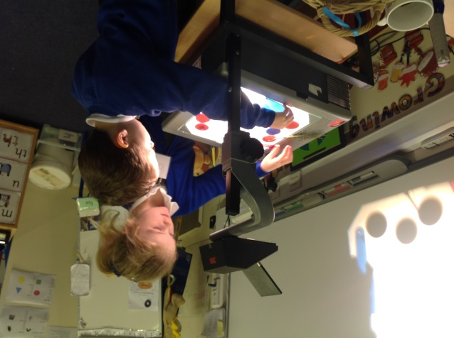
.
The curriculum is based upon each child being a unique learner with three ways of learning which are:

- Playing and exploring – Engagement
- Active Learning – Motivation
- Creating and thinking critically – Thinking

There are 7 areas of learning:

3 Prime areas that are dependent on the developmental stage of the child:
- Personal, Social and Emotional Development
- Speaking, Listening and Understanding
- Physical Development; including health and self care

And 4 Specific areas that are dependent on the Prime areas of learning being established:
- Reading and Writing
- Mathematics
- Understanding the World
- Expressive Arts and Design

All children will have access to the whole curriculum.

RE

In addition, it is a requirement in schools that all children have some religious education unless their parents choose to withdraw them from these lessons.

Learning

Children develop at their own rates and in their own ways. The staff at Chacewater School endeavour to meet the needs of all the children by creating positive relationships with them and their parents and carers.

We provide a challenging and stimulating environment to enable each child to become an active, self-motivated learner.

Learning Journeys

During the year we collate an online Learning Journey which records the progress and learning of your child through their first year at school. You will have access to your child’s Learning Journey through a secure website called Tapestry. See separate details.

We value parents and carers sharing in their child’s learning and we encourage you to contribute to the Learning Journey by letting us know about your child’s interests, achievements and activities outside of school.

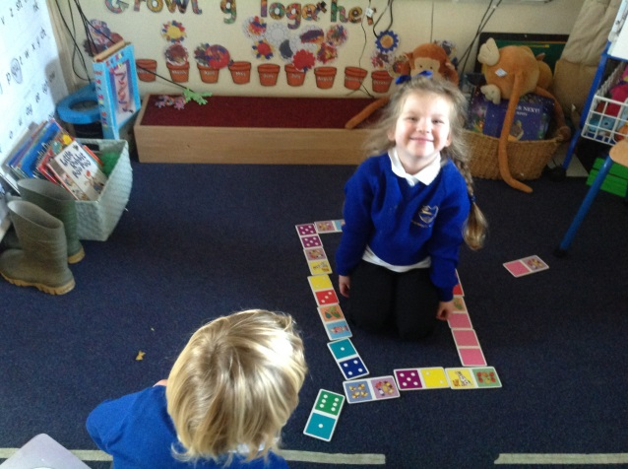

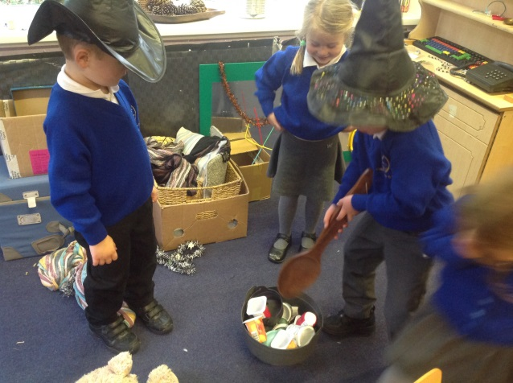

Foundation Stage Profile

Your child’s progress is monitored throughout the year and you will have regular opportunities to meet with the teacher to discuss your child.

At the end of the year the teacher uses all the information collected about each child to complete the Foundation Stage Profile. This is a judgement of the level of achievement attained.

Parents will receive a copy of this profile at the end of the school year and will be offered a meeting with the class teacher to discuss it if they wish.

Reading

Children are given a Reading Record booklet which contains information about letter and numeral formation during their first few weeks at school. Parents are encouraged to help their child choose a library book from the class library to read to their child and talk about it with them.

Please record the title of the book in the Reading Record Booklet and write down any comments you may have.
This is the start of a good habit of reading regularly with your child. Initially you will be reading to your child but quite soon your child will be reading to you!

During the first week or two your child will be given a wordless reading book. This is the start of their journey to becoming an independent reader developing a life-long love of books and reading for pleasure.

You can change the wordless reading book as often as you like. Just make a note of the title in the Reading Record.

The class teacher will be holding a meeting to explain how we teach the children to read during the Autumn term but please feel free to ask me any questions you may have.

Common Questions and Concerns

Parents are often more anxious about their children starting school than the children themselves. The most reassuring thing for you to know is that, although we do have routines, they are flexible and allow for us to accommodate individual children’s needs, especially in the first few weeks. As well as talking to the staff at school, one of our Governors, Vicky Sanderson, has a special responsibility for Acorns Class and she is available to talk with you.

Common Questions:

What shall I do if my child is upset?
Stay for a few minutes, but try to leave as quickly as you can, reassuring your child that you will be back in a little while. Children recover much faster when you are out of sight! We promise you that should your child continue to be distressed, we will contact you. You can also telephone the school if you are sitting at home worrying!

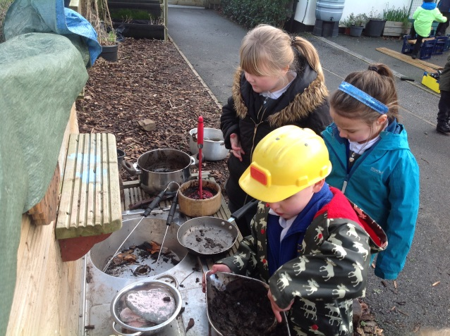

What shall my child do if he needs the toilet?

There are toilets in the classroom area and the children can use them whenever they like. We ask children to let us know when they are going to the toilet so that we know where they are. ‘Accidents’ are bound to happen occasionally, and we deal with them with the minimum of fuss. We have spare clothes in school should they be needed. We are always grateful for any outgrown items to add to our store.

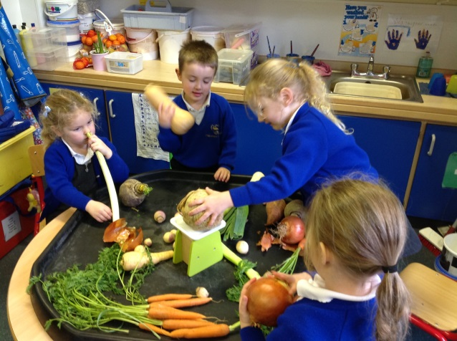

Will my child have to spend the school day inside?

Acorns have an indoor and outdoor classroom which the children use throughout the day; passing freely from one area to the other as they wish.

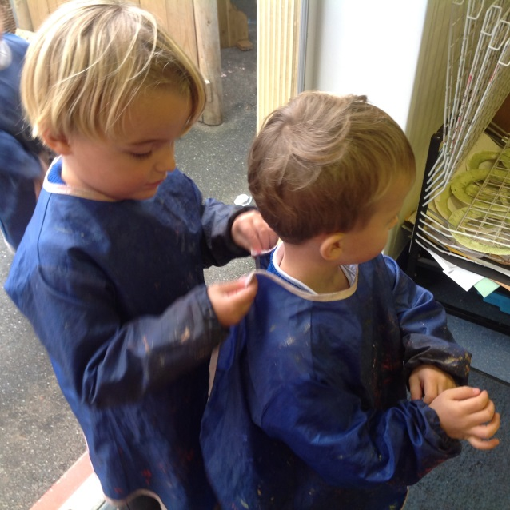

Will my child have to go out to play with the ‘big children’ in the playground?

During the morning playtime session the children share the ‘big playground’ with the children from Seedlings and Buds (Year 1 and 2). At lunchtime Reception age children spend their lunch playtime in our own outdoor area with their own lunchtime supervisor.

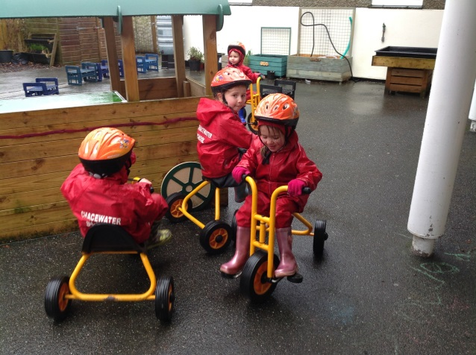

Any other questions

Please talk to Mrs Rice or Mrs Whitehead if you have any questions, we will be only too pleased to try and help.

Finally

The day your child starts school is the beginning of an exciting journey but it is also an emotional day. It’s only natural that you may have concerns about how your child is managing with school life and how they are coping without you. Please let us reassure you that it gets better! Try not to worry – we will always let you know either by telephone or by talking to you at the end of the day if there are any problems at school. We also need you to let us know if you suspect any problems, so that together we can sort them out quickly.

This is a very important time for you and your child. It is the start of a new adventure. It is vitally important to you and us that the years spent at school are happy ones and we try to do everything possible at Chacewater School to make them so.

