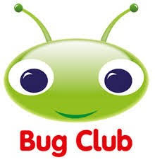

Monday 1 June 2020

Dear Buds,

Whilst continuing home learning we have subscribed to ‘Bug Club’ on Active Learn Primary to enable your child to access a wide range of appropriately levelled books. These levels may not exactly match the levels your child was assessed at back in the Spring, but I hope they will be a way in to returning to some kind of daily ‘school reading’ normality.
The books we allocate should be at a level that your child can read - if they are too hard please let me know and I can adjust the levels.
You should be able to access the Chacewater School area of Active Learn and then use your child’s personal login details below. When you should find a small selection of books. There’s a ‘grown ups’ tab where you can see the possibilities for questions and activities.
We will be able to see the books your child has read and how they did on the questions. We’ve set the book allocation to a maximum of 5-10 and we’ll review Bug Club weekly on a Friday.
Please continue to enjoy your books from home to give your child a breadth of reading opportunities. There’s an awful lot of online reading material available (links on our webpage) and we hope that Bug Club will provide another dimension to this.
Please use our Buds email address if you want to talk to me about this or need more support to access it.

Kind Regards

Mrs Morgan and Mrs Buckingham
https://www.activelearnprimary.co.uk/
username
Password
School ID | chmd

