MIGHTY OAKS
CURRICULUM LETTER – SPRING 2017
Dear Parents,
Welcome back. We hope you had a great Christmas. This term our two main topics are: ‘Who’s the Mummy?’ and ‘The Battle of Britain – Bombs, Battles and Bravery’.
‘Who’s the Mummy?’
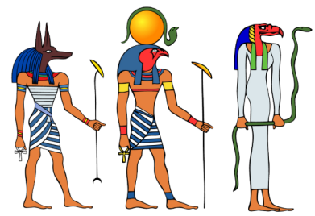
This unit is based on a study of Ancient Egypt, with the main focus being mummification. The children will have the opportunity to learn about the mummification process by embalming their own fish and become tomb explorers that find a series of mysterious objects that need to be identified. They will explore ancient Egyptian myths and discover why Egypt’s position in the world made it such a powerful country.

‘The Battle of Britain – Bombs, Battles and Bravery’.

In our second topic of the term the children will find out what it was like to be a child in Britain in WW2 and about the importance of the Battle of Britain. In history, pupils will find out about evacuation and how difficult that was for parents and children. In English, they will write evacuees diaries, war stories and poems. The science in this Unit is the study of light and in the context of WW2 pupils will study what a Spitfire pilot could see, how searchlights used reflective light and why the blackout was so important. They will also make their own periscopes.

Maths
This term we will be focusing on: fractions, decimals and percentages; shape, space and measure; properties of number and time. We will also continue to practice calculation strategies and look at Egyptian maths (puzzles, Egyptian numbers and Egyptian multiplication).
IT
The children will make their own animations describing how the mummification process works
PE
This term we will be focusing on cricket skills and gymnastics
French
It is now a statutory requirement for junior children to learn a foreign language. As part of the Inspire curriculum, French is linked to the topic and will be taught by Mrs Hunt.

RE
Homework
Spelling – Given out on Monday. Reinforced throughout the week. Tested on Friday.
Maths - Given out on Friday. Please return to school on the following Wednesday.
English – Given out on Friday. Please return to school on the following Wednesday.
To support homework we will be continuing to use the Rising Stars revision books for 6
Daily reading:
Reading is the one of the most important and valuable activities you can do with your child. Sharing and enjoying stories impacts on all other areas of a child’s learning and development. However, at this stage children generally become more independent and as such should take increasing responsibility for their reading choices and responses. The key is ENJOYMENT! The reading records will continue to be an important part of their learning and give your child the opportunity to develop their reading responses. We will go over what is expected within school. It is essential that reading books and records are brought into school each day, in order that they can be checked regularly and rewards given for commitment to reading.
If your child has any problem with their homework it is important for them to inform us as soon as possible. There is also the opportunity for your child to attend homework club on Tuesday lunchtime with Mrs James which is open to all year groups.
Finally, as you know, our Year 6 will be facing some new assessments in May which all children in Year 6 in England will also sit. This is a crucial term where we will be helping the children to be prepared as they can be. We would appreciate your continued support at home but as always if you have any queries please feel free to contact us. A reminder that the SATs tests are the week commencing…
If you feel that you have any skills or interests that could support us (particularly linked to our topics) please let us know and do not hesitate to contact us if you have any queries or concerns.
Yours Sincerely,

Mrs James and Mr Gould

