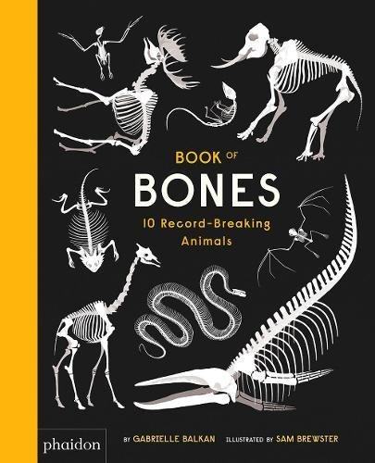
Half term homework!
Your home learning for half term is to research an about an animal for our English class book that we will write all about animals and their bones!! We have read the WAGOLL book ‘Book of bones: 10 record breaking animals’, so you should have a good idea what type of things you need to find out. What make that animal special, facts and numbers about the animal, where it comes from etc. You can use the template below to help you collect information.

Here are some animal suggestions we came up with:
- Leopard gecko
- Polar bear
- Jaguar
- Cat
- Tiger
- Leopard shark
- Crocodile
- Flamingo
- Lion
- Great Dane /chihuahua
- Penguin
- Sugar glider
- Panda
- Owl
- OTHER…

My animal | EG: Chihuahua
Where it’s from | Mexico
Facts and numbers  (size, number of bones, lifespan etc). | It’s the smallest breed of dog in the world.  A feral pack took over a town in Arizona in America in 2014.  There are two different types of head – apple and deer.  There are different types of coat, long and short.  They come in different colours – Mearl, black, grey, white, gold.  Earliest know pet to be kept by the Mayans in 1800 BC.
Other interesting information | It was a popular dog for celebrities to have in the 2000’s as it was small, cute and colour fit into a bag.  They have shrunk over time.  Christopher Columbus brought them over to Europe.
Picture of its bones | 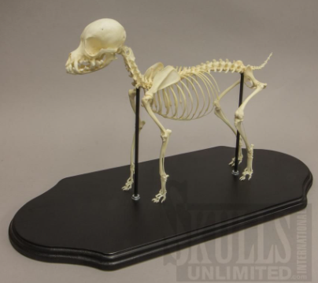
Picture of it | 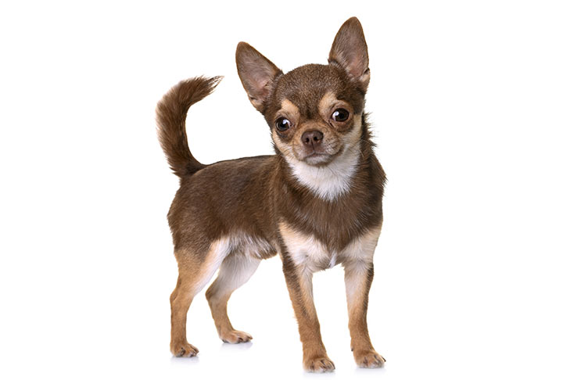

My animal
Where it’s from
Facts and numbers
(size, number of bones, lifespan etc).
Other interesting information
Picture of its bones
Picture of it

