Buds topic homework – October – December 2018

This half term our topic is all about flying. For a topic homework, we would like you to create something that flies – it may be an animal, an invention or an object of your choice.

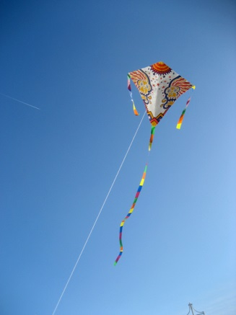
You can choose which way you would like to present this; you can get creative and physically make something with arts and crafts, you can design something and label how it would work on paper or you can make it electronically.
Examples from the past are papier mache aeroplanes, paper hot air balloons and giant flying animals!
Please ensure these are brought in to school by the 1st December so that we can showcase them in class.
Any questions, do not hesitate to ask and please make sure you have lots of fun together!
Kind Regards
Mrs Fox and Mrs Saxton

