Dear Children
Some classes are going back to school. I know that this has been a weird and strange time. Everyone at school has missed you terribly and we can’t wait to see you.
When you get back some things will be the same and some things will be different.

Things will be a little different-
- Not all classes will come back. Only Reception, Year 1 and year 6 at the moment.
Reception Year 1 Year 6

- Your class will not be as big. Each class will only have about 15 children in it (no bigger)

- You might not be in your normal classroom and with your normal teacher but it will be with children you know and a teacher you know.
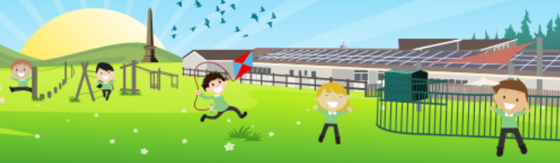

- Your small class will not play with other classes during the day. You will have your very own playtime and lunch time. You can still wave and say hello from a distance.

- We normally say sharing is caring but at the moment in school we are not going to share equipment. We can still share encouragement, and kind words.

Good Job!

- We will be washing our hands a lot and catching our coughs and sneezes.
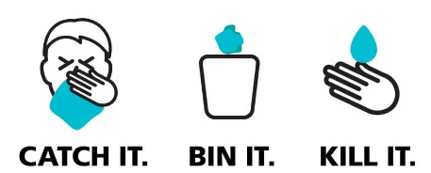

- We will be trying to stay 2 metres away from each other.
2 metres

BUT IMPORTANTLY

- There will be lots of lovely adults who will listen and support you with your work and play

Have a lovely holiday next week

Yours Faithfully

Mr Gould

