STOP AND ACT!
What is Bullying?
In our school a bully is someone who hurts someone more than once, by using behaviour which is meant to hurt, frighten or upset another person. We promise to always treat bullying seriously.
Bullying can be:
Emotional: Hurting people’s feelings, leaving you out, hand signs, being put down or humiliated, having money and other possessions taken or messed about with, having rumours spread about you.
Physical: Punching, kicking, spitting, hitting, pushing, pulling, being threatened or intimidated.
Verbal: Being teased, name calling.
Racist: abusive behaviour towards members of another race or culture.
Cyber: saying unkind things by text, app, e-mail or the internet.
Homophobic: calling you gay or lesbian.

When is it bullying?
STOP =
Several
Times
On
Purpose

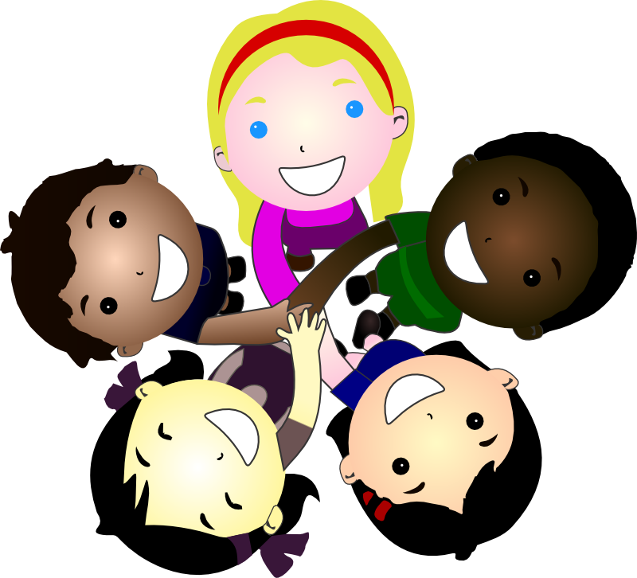
Who can I tell?
ACT=
Ask the bully to stop
Collect a friend or witness
Take them and tell an adult
If you are being bullied:
Start Telling Other People!

If you are bullied
• Ask the bully to stop. Use eye contact and tell them to go away.
• Collect a friend or witness.
• Take them and tell an adult.

DON’T:
• Do what they say.
• Get angry or look upset.
• Hit them.
• Think it’s your fault.
• Hide it.

What should I do if I see someone else is being bullied?
• Don’t walk away and ignore the bullying.
• Tell an adult what you have seen.
• Tell the bully to stop if it is safe to do so.
• Don’t stay silent or the bullying will keep happening.

