Class: Name:
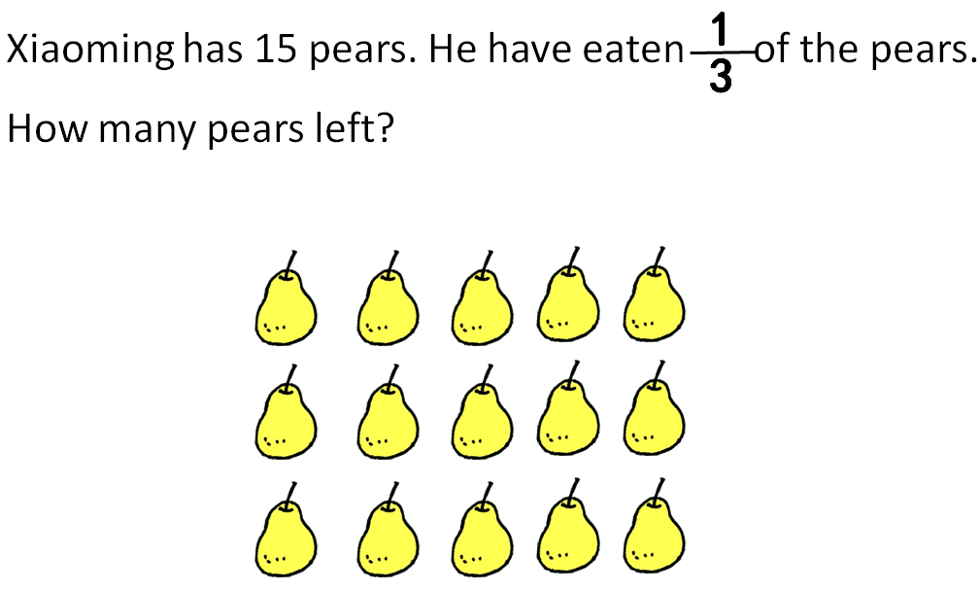

Can you explain why?
You can use number sentence to explain.

