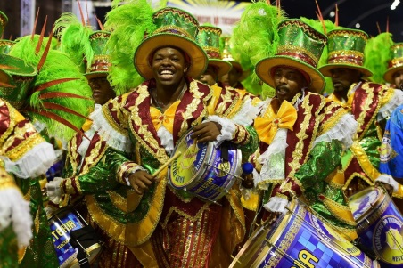
Summer term 2018

Dear Parents,
As we approach summer and the days feel longer we are off to warmer climates too with the start our new topic: trading places, Britain or Brazil? The children will learn about Rio De Janeiro looking at where it is in the world, Rio Carnival, samba dance and we will create our very own samba music. The 2nd half of summer term our topic will be all about ‘Pirates’. Please find attached a copy of a curriculum map which shows the learning in Literacy, Geography, Art, DT, and Music covered through the first topic.
English: We will be writing letters using a variety of sentence types and focus on the use of a range of punctuation; questions and apostrophes for contraction. The children will be developing their understanding of spelling patterns, punctuation and grammar. Please remember to log on to Active Learn: Grammar Bug to see the grammar and spelling games to play. We are having a big focus on handwriting; in particular correct hand grip and now showing some of the joining we have been learning in our handwriting lessons.
Mathematics: We will be learning about: number and place value, addition and subtraction, multiplication and division. The children will continue to apply maths skills to practical contexts including reading scales, statistics and measure. We have recently been learning to tell the time to the nearest 15 minutes and nearest 5 minutes. Please practise this skill at home.
Science: In science this half term the children will be learning about materials and their properties.
Geography: They will learn about where Brazil is located within the world and the continents of the world. They will describe the important differences that a visitor to Brazil would need to know. We will look at the differences between rich and poor people and describe living conditions in a favela for children.
Art/ DT: We will look at how Brazilian children dress for carnival and the types of colours and fabrics used. They will design their own carnival t-shirt and decorate a carnival mask.
RE: We will learn about the Christian religion hearing stories from the bible.
Computing: The children will learn about being safe on the internet and create their own poster about Brazil.

PE: Our PE lessons will cover gymnastics, dance and outdoor games. Children should have a NAMED PE kit in school at all times. (Blue t-shirt, black shorts, jogging bottoms for when it gets colder if required, trainers or plimsolls with Velcro fastening (unless your child is able to manage their own shoe laces). If your child wears earrings in pierced ears then these will be covered with tape for safety. Long hair should be tied up for school. Mrs Saxton will be teaching outdoor games on a Wednesday afternoon.
PSHE: ‘Living in the wider World’ our topic areas which we will cover are; Rights and responsibilities; Taking care of the environment; Money matters.
99 Club
The children will continue to take part in the weekly mental maths 99 club. The weekly question sheets will be completed on Tuesdays.
Homework
Spellings are given out on Thursday and will be tested the following Thursday. The children will be learning these rules in the lessons during the week.
Maths homework will be given weekly;
Help your child to tell the time to be able to read the time to five minute intervals using an analogue and digital clock.
Daily Reading
Reading allows your child to absorb the world around them, I am sure you have noticed a great improvement in your child’s ability to read, so still continue to encourage that love of reading. Sharing books together, whether at bedtime or them reading their banded book/AR books to you is a great way to read at home.
Parents are welcome to come into the Buds classroom on Fridays from 8.40 to 8.55 to help their child change their reading book and to pop in to see the children’s learning.
Lunches
All Year 2 children are entitled to a free school meal every day. Remember there is online booking now to pre-order your child’s lunch.
Assessment
At the end of Year 2 we have to report to the government where your child’s attainment is in line with National Expectations for maths and English. This is based upon teacher assessment but is also supported by some national tests which the children will undertake during the month of May. If you would like any more information please see Mrs Morgan or Mrs Saxton.
Yours Sincerely
Mrs Morgan and Mrs Saxton

