Seedlings Topic Homework
Posting and places
This term our topic is all about looking at other continents and making comparisons, the seedlings are required to create a project about a continent of their choice and comparing it to our own (Europe) – try to encourage them to be as creative as possible with their choice!
They can choose the way they present their project (powerpoint, book, poster, photographs, pictures, writing, acting etc) and have until w/c – 2^{5th} May to complete it.
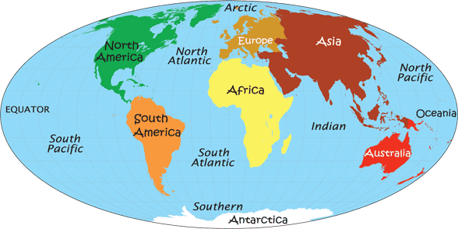
We were focusing on money last term and to incorporate maths it would be lovely to see them include this. I would like them to ensure that they cover all of these areas within their project:
- The weather
- Currency
- Any interesting facts
Enjoy creating this project with your child, I can’t wait to see them!

Any questions, please do not hesitate to ask,

Many Thanks

Miss Sturges
(Seedlings Teacher)

