Early years foundation stage profile: What you need to know

What is the early years foundation stage profile?
The early years foundation stage (EYFS) is the period of learning from birth to age 5 – before key stage 1 begins in Year 1.
The EYFS profile is an assessment of children’s achievements at the end of the Reception year – the last year of the early years foundation stage.
Children are assessed against 17 early learning goals. The child’s profile will include whether children are below, at or above these goals – known as emerging, expected or exceeding the level expected by the end of reception year.
The profile also includes a paragraph on how children demonstrate three “characteristics of effective learning” which are: playing and exploring, active learning and creating and thinking critically.

What do the early learning goals cover?

There are 3 prime areas of learning (Communication & Language, Personal, Social & Emotional Development, and Physical Development) and 4 specific areas of learning (Literacy, Maths, Understanding the World, Expressive Art & Design. These are divided into the following aspects:
- Listening and attention
- Understanding
- Speaking
- Moving and handling
- Health and self-care
- Self-confidence and self-awareness
- Managing feelings and behaviour
- Making relationships
- Reading
- Writing
- Numbers
- Shape, space and measures
- People and communities
- The world
- Technology
- Exploring and using media and materials
- Being imaginative

Are children tested on these?
No. Teachers observe children in a range of daily activities and use this knowledge to assess whether children have met the goals.
Most evidence is expected to come from teachers observing what children can do without being prompted by adults, but adult-led activities can also give teachers an insight into what children can do.

Why include the characteristics of effective learning?
These were introduced as part of the review of the EYFSP by Clare Tickell in 2011. She said that an explicit statement on how children were learning – as well as what they were learning – would help teachers guide children’s development as they go through school.

How is the profile recorded?
Practitioners record evidence of their observations and complete a profile summary which is submitted to their local authority. Local authorities have a duty to moderate judgements in their area to ensure they are consistent.
Teachers are told that evidence “doesn’t need to be formally recorded or documented” and that “paperwork should be kept to the minimum that practitioners need to illustrate, support and recall their knowledge of the child’s attainment”.
At Chacewater School we use a range of tools to record evidence: an online Learning Journal (Tapestry), a folder containing examples of work children have made, a writing book and teacher knowledge. All of these elements are drawn together to create the profile summary.

Who gets the information?
Schools must share “a written summary of a child’s attainment against the ELGs” with parents. The report must show whether a child is not yet reaching, at or exceeding the expected level for each ELG, summarise attainment and comment on the characteristics of effective learning.
Year 1 teachers must be given a copy of the EYFS profile for each child.
The DfE will publish national and local authority data, but not school-level data. There are no EYFS league tables.

How do children get on?
In 2016, 69.3 per cent of children achieved the "good" level of development. This benchmark is achieved when a child has achieved at least the expected level in each of the first 12 early learning goals.
Writing is the goal that fewest children reach – 72.6 per cent of pupils were at or above the expected level in 2016. In contrast, the goal which was most commonly achieved was technology - which 92.4 per cent of children reached or exceeded.
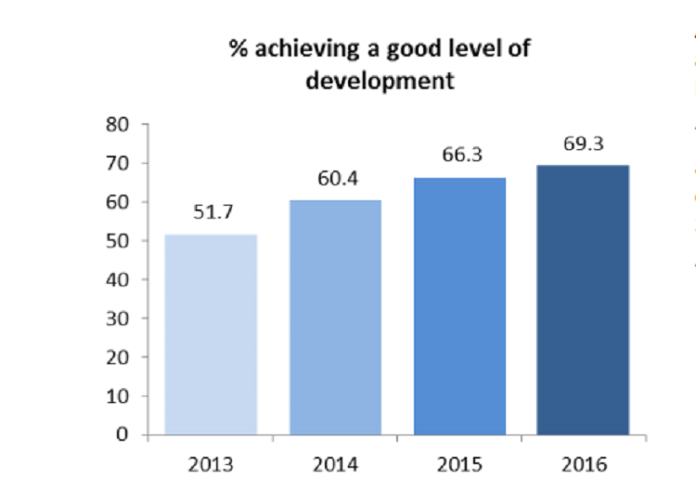

Source: DfE

