Chacewater School – LEAP into Learning
Term: Autumn term 1 | Class: Year 1 (Seedlings) |  | Theme: The Big Build/All about Me!
On this page you will find an outline of our learning this half term in Seedlings class.
Maths: Place value  Use objects and pictures to represent and identify numbers.  Read and write numbers from 1 to 20 in numerals and words.  Use language like equal to, more than, less than (fewer), most, least.  Use objects and pictures to represent and identify numbers  Count more or less from a number.  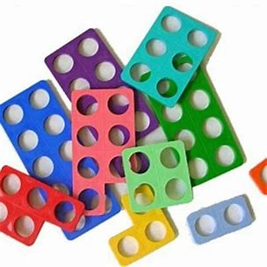  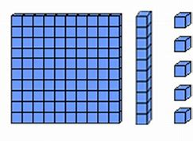  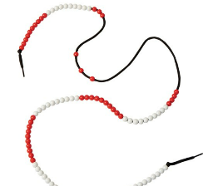  Numicon  Base 10/dienes  Bead string |  | Science: Materials  Children will be able to identify and name a variety of everyday materials. They will begin to learn their properties and take part in an investigation to find out which materials are waterproof.
Religious Education: Christianity
- Children will recognise that ‘Creation’ is the beginning of the ‘big story’ of the Bible and be able to share the story with others and create artwork to sequence this.

RHSE: Happy and Healthy relationships
- This sequence of lessons will be exploring healthy and happy friendships, focusing on forming friendships and what makes a good friend. Our value will be kindness – what does this look like? Why is this important?
- We will also continue to learn about The Colour Monster – recognising our feelings and be able to share what to do if a friendship is making us feel unhappy.
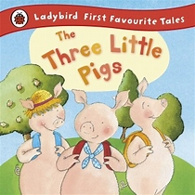  English: The Three Little Pigs  - Our class text is ‘The Three Little Pigs’ and we will write a short story with a simple beginning, middle and end. Children will be able to write short sentences, applying their phonics knowledge for accurate spelling and proof-read their work to check that it makes sense.  - We will follow a 5-day phonic programme (RWI) where children will work in groups to read, write, spell and practise handwriting. We learn by writing sentences and will be able identify them in our RWI story books.  Grammar:  - Continuing to use capital letters and full stops correctly and consistently.  - Using capital letters for names and forming upper and lowercase letters accurately.  - Presentation: writing our letters on the line and using ‘finger spaces’ between words to ensure our writing is legible. |  | Computing: Technology around us  Children will understand and recognise the uses of technology at school and in the wider community. They will learn how to use a computer and its features.  To understand how to be safe when using IT and how IT can be used in different ways.
Art/DT: Sculpture making
Children will explore and investigate with materials to develop their drawing skills in line, pattern and shape. They will be introduced to observational drawing and explore our school grounds to create realistic pieces of art.
PE:
Outside: Multi-skills – invasion games - listening to instructions and working within a team.
Inside: Real PE – focusing on balance and co-ordination.

Chacewater School – LEAP into Learning
HOME LEARNING
Term: Autumn 1 | Class: Year 1 (Seedlings) |  | Theme: The Big Build/All about Me!
Alongside regular reading, spelling and maths home learning, choose at least one of the following to complete over this half term. You might even be inspired and choose more than one!
Please send any work into school or take a photo and email our class: Seedlings@chacewaterschool.co.uk
RE  Creation  Watch this video about God’s Creation (Genesis 1-2) and draw a comic strip to sequence each day.  Creation (Genesis 1-2) - Bing video  Challenge: discuss what the world would be like if these things did not exist. |  | Science  Materials hunt  Look around your house and list all of the objects/items you can find that are made from: glass, wood, plastic, metal, paper. Make a poster to show and label the objects you find.  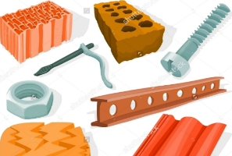  Challenge: discuss why certain materials are better suited than others (e.g. metal is a more suitable material to make a spoon from because it is strong and will not bend). |  | PSHE  Being kind  Make a friendship card for somebody in Seedlings class. You could write them a compliment or a quality you like about them. You could also make a card for someone you would like to become closer friends with.  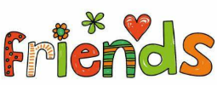
All about Me  I am unique  Make a poster that tells Seedlings all about you! Include a photo (or draw a self-portrait), your age, your favourite hobby/food/book/colour and one fascinating fact so that we can learn even more amazing things about you! |  | Maths  Number  Number formation 0-20. Practise counting aloud 0-20 and write the numbers correctly (watch out for numbers 4,5,7,9). Can you find objects at home and place them underneath your number? Can you write and read the number as a word? Practise counting forwards and backwards. Can you find two numbers that make up one number (e.g. 2+3= five). |  | Geography  Locality  Research Chacewater village and write some simple facts about what find. You could turn this into an information leaflet and include your own diagrams/labels.  Challenge: can you find Chacewater school on Google Earth? Which country and county so you live in?
PE  Yoga – balance and co-ordination  Choose a yoga video from: Cosmic Kids Yoga - YouTube to practice your balance and co-ordination. I really like the Superhero Kids one! |  | Click here to play.  https://play.numbots.com/#/intro |  | Art and Design  2D creative Art  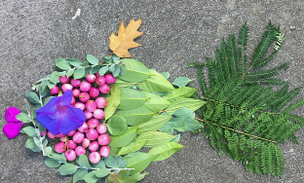  Go on a nature walk and find natural materials and create a picture of a house you would build for the Three Little Pigs. What features would your house have? Can you stop the wolf from blowing it down? You can be as creative and imaginative as you like!

