Chacewater School – LEAP into Learning – Autumn 1 – Seedlings
Science: Everyday materials
Our enquiry: Which materials should the Three Little Pigs have used to build their houses?
What I might already know: I can name some materials and explain why they are used.
Everyday materials and their properties |  | Vocabulary
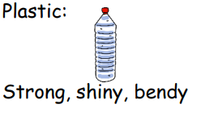  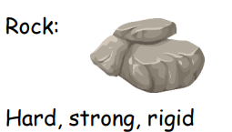  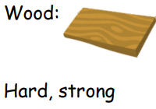 | 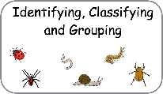  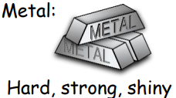  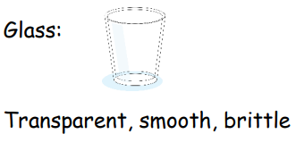  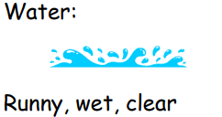 | Hard  Not easy to break  Soft  Easy to fold, cut or change shape  Stretchy  Can be made longer or wider without breaking  Brittle  Hard, but may break easily  Shiny  Reflects light easily  Dull  Not very shiny or bright  Squashy  Easily crushed or squeezed | Rough  Has an uneven surface  Smooth  An even surface with no lumps or bumps  Bendy  Can be bent easily  Waterproof  Keeps water out  Absorbent  Easily soaks up liquid  Transparent  Easy to see through  Opaque  Cannot be seen through
Key facts!  - You can tell different materials apart by feeling them. Are they hard or soft, flexible or stiff?  - Materials are used for different reasons. Some materials are better than others for certain objects; for example, metal shoes wouldn’t be very comfortable to wear and a cardboard door wouldn’t be very strong!  - An object can be made out of different materials used together; for example, a chair can be made from metal and wood. A pencil is made from wood and lead. |  | 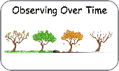  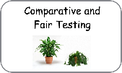  What we will be learning:  - How to carry out an investigation to find out which materials would be the most suitable to build a strong house.  - Testing materials to find out which ones are waterproof.  - Observation overtime – what happens to ice if we leave it on the windowsill?

