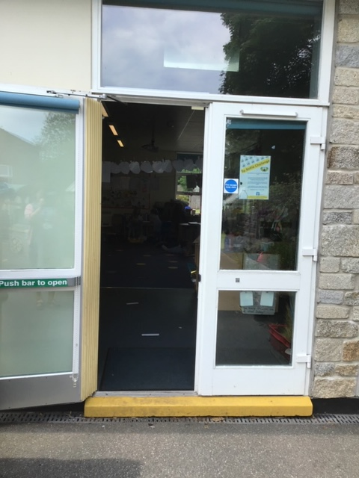
When you come to school in September. This will be the door you enter to start the school day. This door is also used to go out for playtime and is attached to our outdoor area.

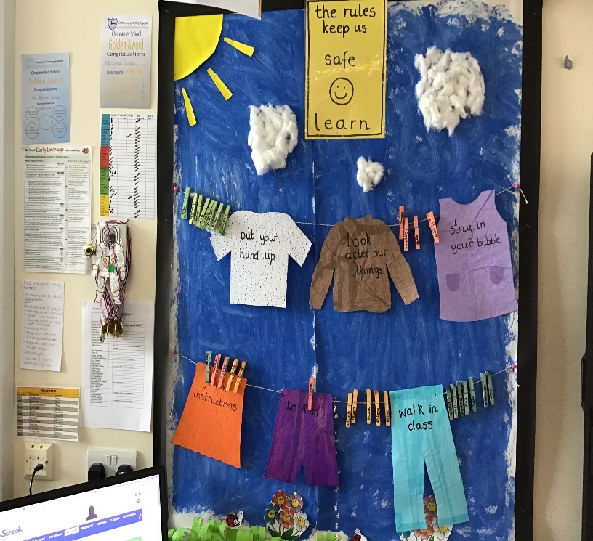

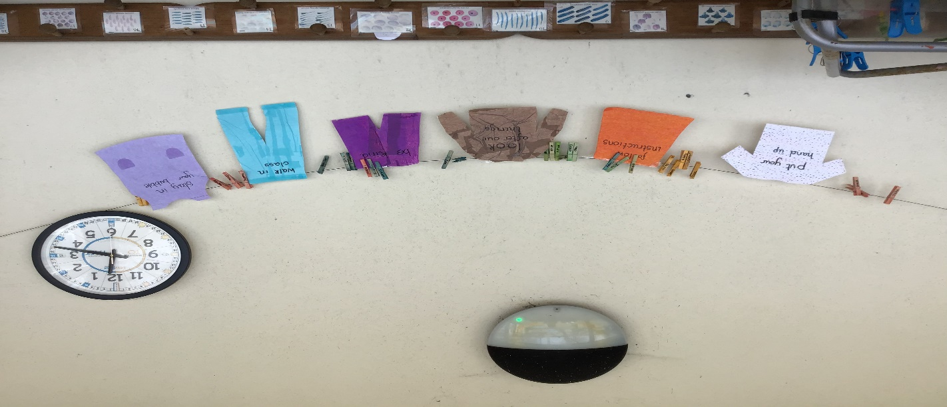
This is a picture of our new behaviour chart. It is a washing line with all of our rules we need to follow whilst in school. We will decorate our name cards for our chart in the first few days at school. To remind us, we also have the rules in our outside learning space as well.
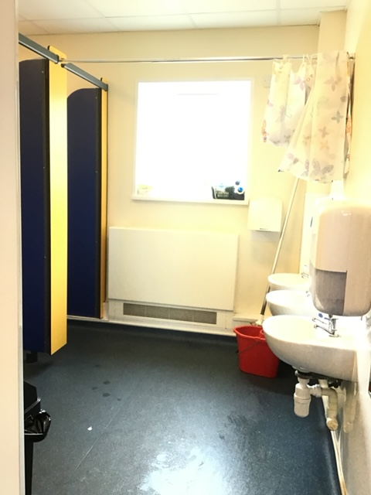
This is a picture of our toilets that we have in the Acorns Class.

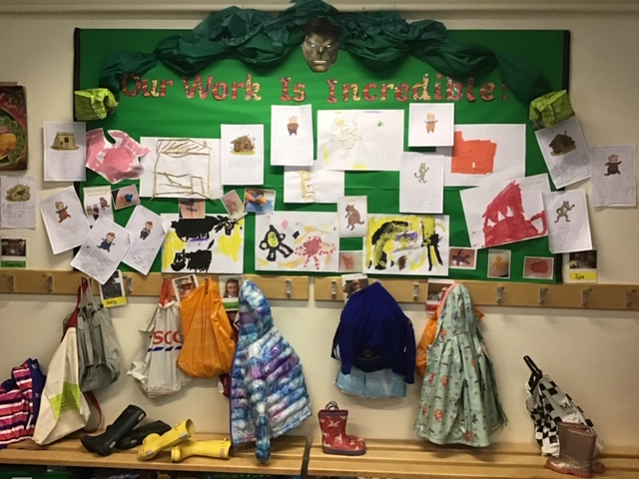

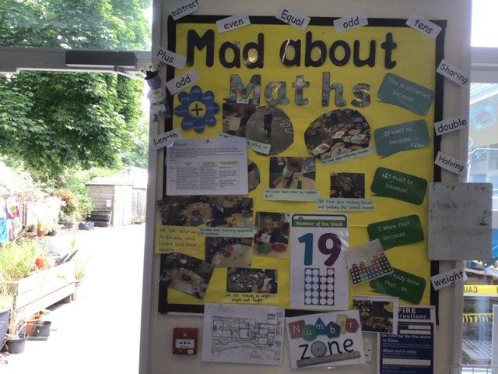
We have lots of displays in our classroom and this is to showcase all of your work. Recently we have just made a new display that says ‘Our Work Is Incredible’. This display will still be here when you arrive in September. This is also near where we hang up our coats and bags as well.

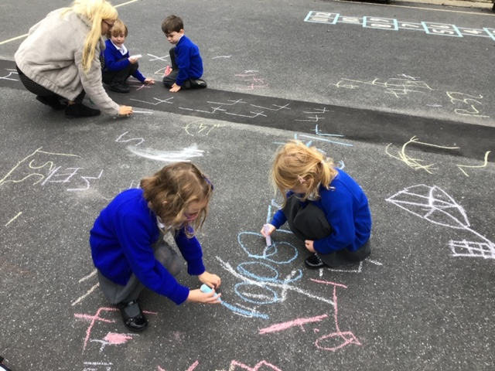
This is a picture of the outside ‘big’ playground. We use this playground for break times. We also go out and use the bikes in this playground, as well as lots of other fun learning opportunities.

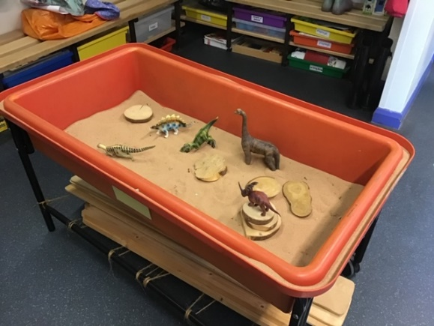
We have lots of lovely things to use and play with in the Acorns class and we have just updated our outside learning space with lots of lovely new resources for us to use. Here are some pictures for you to have a look at.
