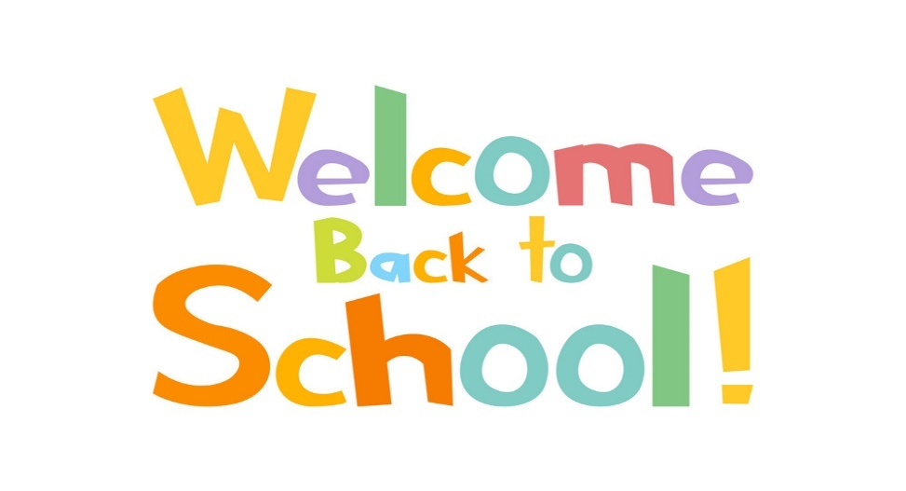
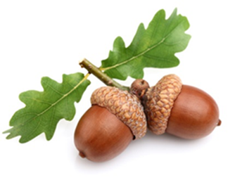

Dear Parents
Spring Term Curriculum Letter
Welcome back to the Acorns Class, we hope you had a wonderful Christmas Break. We are very excited to be back and welcoming your children into their second term at Chacewater School. We have lots of lovely learning and exploring to be getting on with.
This newsletter gives you an insight into the children’s daily routines in the Acorns Class and what we have planned for your child’s learning this term. Your child’s day consists of:
- Morning jobs – this term, your child will be familiar with their daily jobs. They will need to choose a reading book, sign in their name and be responsible for their own belongings.
- Hello Acorns! Let’s see who is in class and think about our day ahead – take the register and explain important messages.
- Getting Busy/ Lovely Learning. The inside/outside classroom will be set up at different points in the day to provide a range of provocations for children to explore. The adults will support and observe so we can make sure everyone is challenged and engaged. This will lead into teacher-led activities as the term goes on.
- Read Write Inc (RWInc) - Phonics. We will continue with a structured phonics (RWI) lesson in the mornings, where your children will work with either Mrs GT, Mrs White or Mrs Booker. We will also be learning our set 2 sounds this term – keep an eye out for the RWI booklets that will be sent home this week. These will include the sounds we have learnt, along with some additional handwriting practice.
- Maths. There will be a daily teacher-led input for maths to teach core skills wholly as a class. The classroom will then be divided into 4 stations and each child will work alongside an adult completing an adult led task. There will also be opportunities for children to explore provisions set out and challenge their mathematical minds. We will supply children with investigation lessons when teaching something new. This will allow children to show the class teacher what they already know and this will enhance planning, ensuring all children are being challenged to their full potential. We are currently looking at doubling and halving
- Topic Lessons. Our first Topic for our afternoon sessions this term will be based on ‘Superhero’s. Here your child will learn about superhero’s well known to them, along with superhero’s that come in all different shapes and sizes. They will underpin what makes a superhero special and we will talk about the roles of different people amongst our community and in our local area – after all superhero’s don’t always wear capes! There will be opportunities this term to meet those in the community that help us – we are hoping this will include a visit from the fire brigade. Children will then continue their learning after the half term where we will delve into our next topic - ‘Amazing Animals’.
- Outdoor Adventures. Every Wednesday Afternoon we will run outdoor adventure for Acorns. There’s no such thing as bad weather – only bad clothing! For this your child will need to come to school with:
- Wellies
- Wet weather gear (all in ones) (waterproof trousers etc)
- Warm/old clothing (we may be getting mucky).
- Assembly. We now attend weekly assemblies with the rest of the school – these take place on Monday’s and Fridays.
You will notice this term that we have introduced a book bag made for our class characters – Mr and Mrs Monkey. Mr and Mrs Monkey will be sent home with reading books related to the termly topic every week with a child of choice. This is to promote a love of reading to children from the earliest of ages, but to also allow your child to talk about their adventures with Mr or Mrs Monkey and what they got up to over the weekend. We would then appreciate if your pictures taken could be uploaded onto Tapestry. We will then show these in our class, promoting class discussions.
As you know, we are continuing to use our online learning journey programme called Tapestry. Please have a look and update anything you may be doing at home that your child would be happy to talk about in class.
With best wishes
Mrs Glanville-Thomas
Acorns Class Teacher

